**Xamarin.Android App**

**Adding ImageView to the app**

> Add an image in the Resources > drawable folder (in this case the image is named logo.png)

> Add this code to the Main.axml file

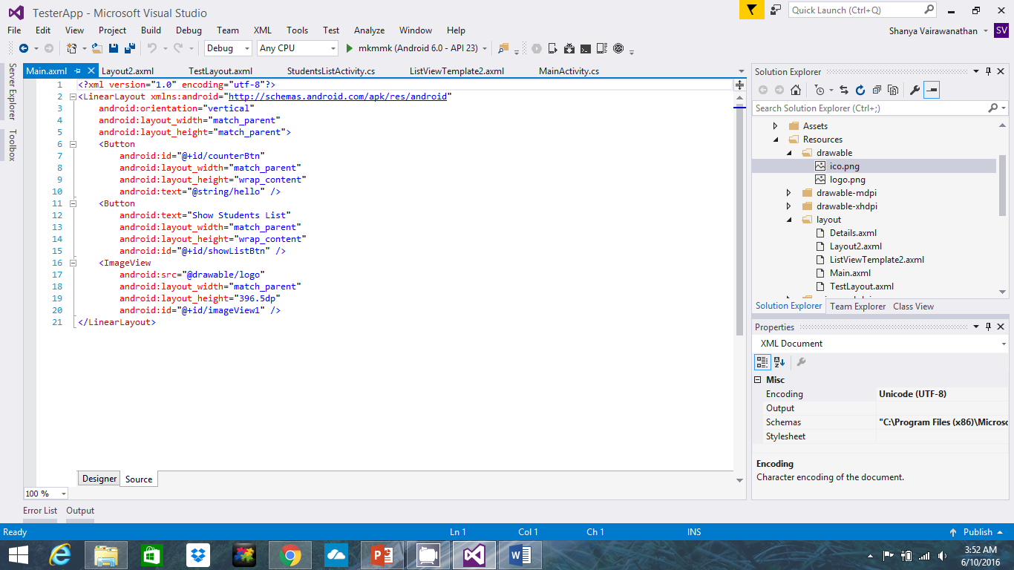

>The app will look like this (the height and the width of the image can be changed using the “android:layout_width” and “android:layout_height”) :

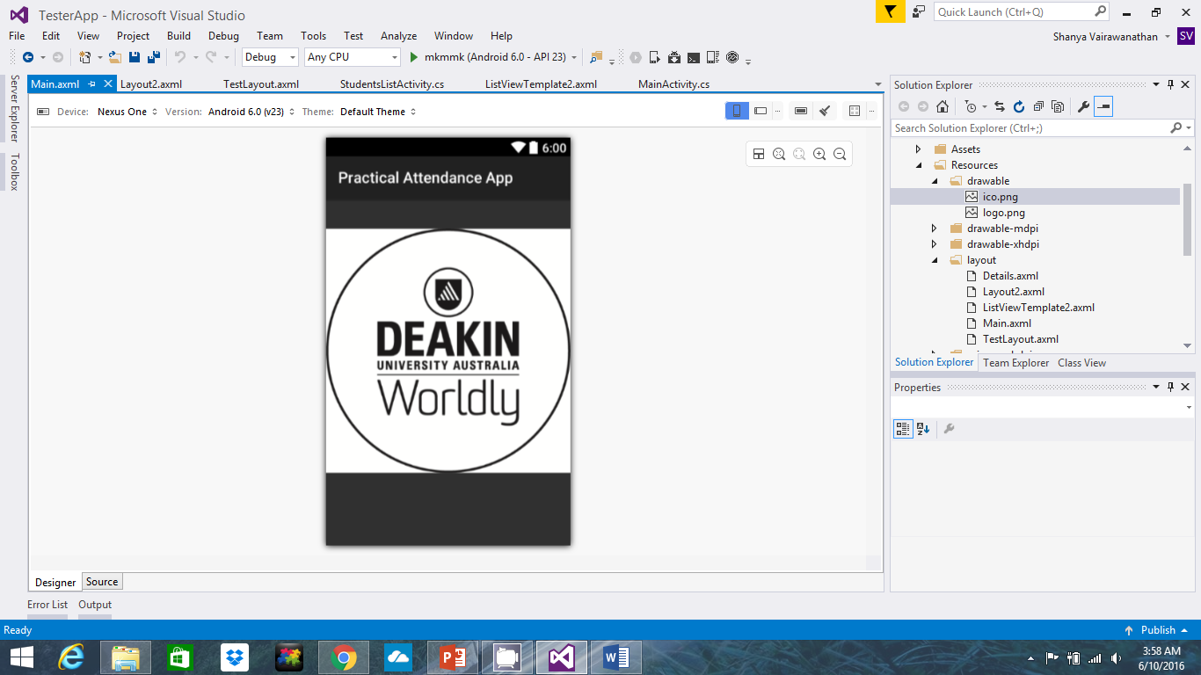

**Adding ListView to the app**

> Add the following two buttons to the Main.axml file. This button allows the user to go to the StudentLisActivity page.

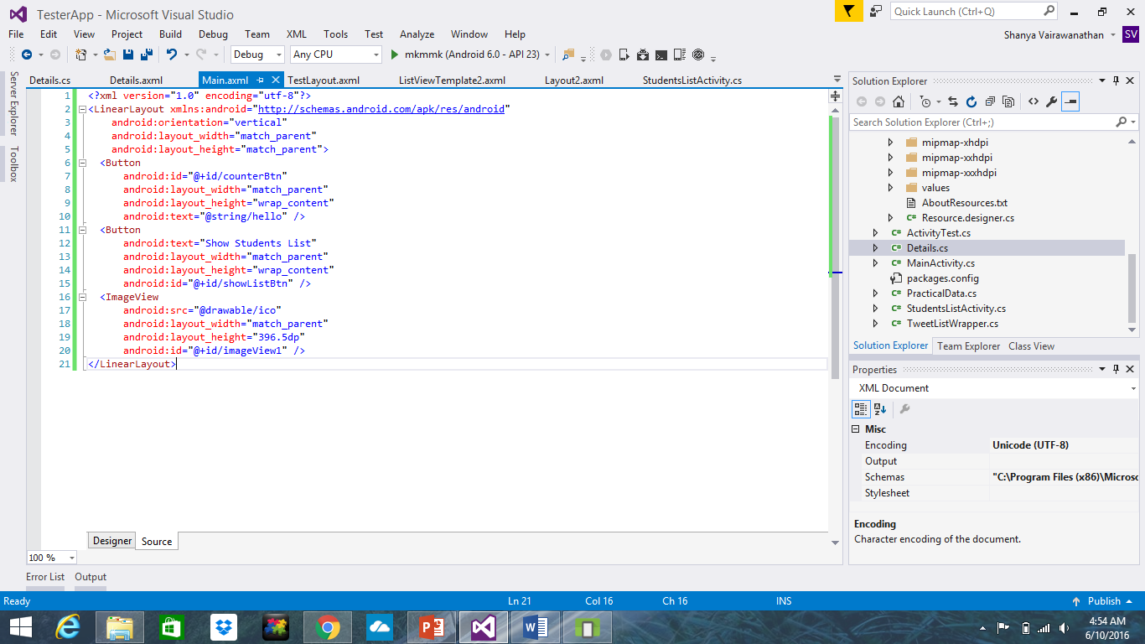

> Add the following code to the MainActivity.cs file. This allows the user to perform an event when clicking on a button. In this case it allows the user to go the StudentListActivity page.

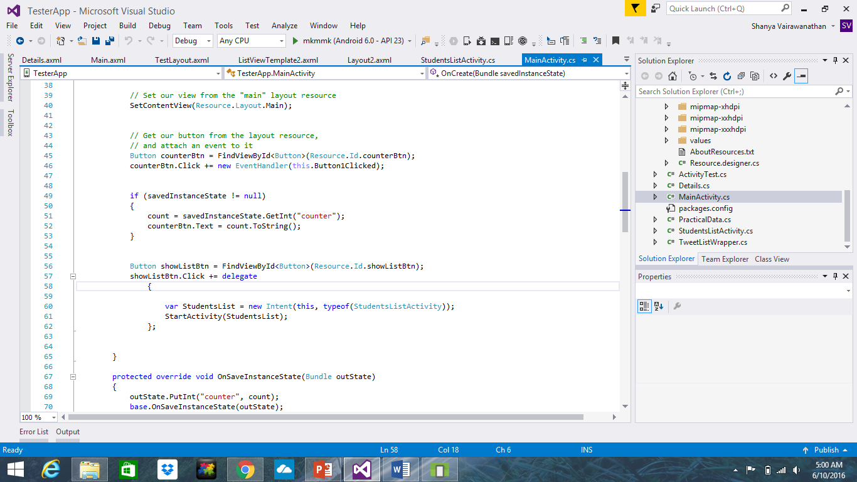

> Create a StudentListActivity class.

> Create and add this code to the StudentListActivity class axml file

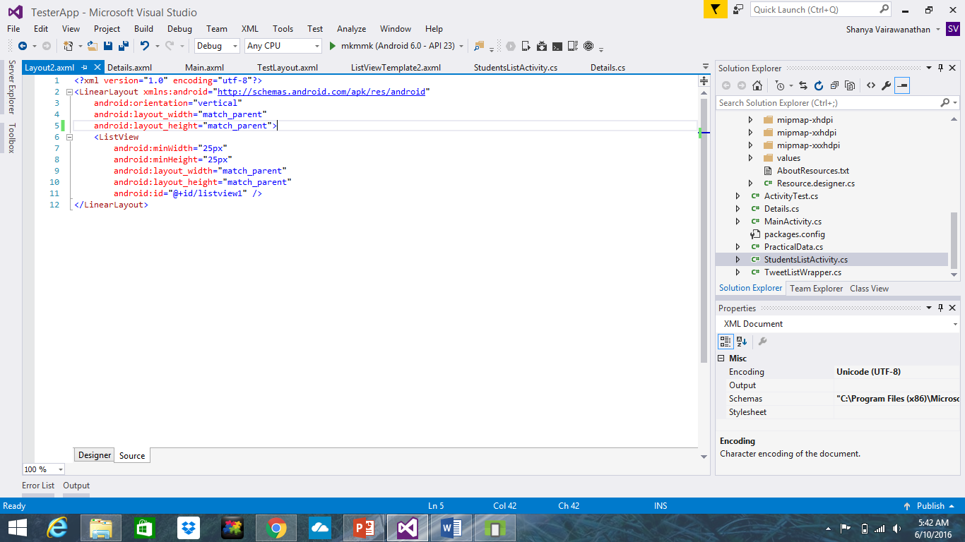

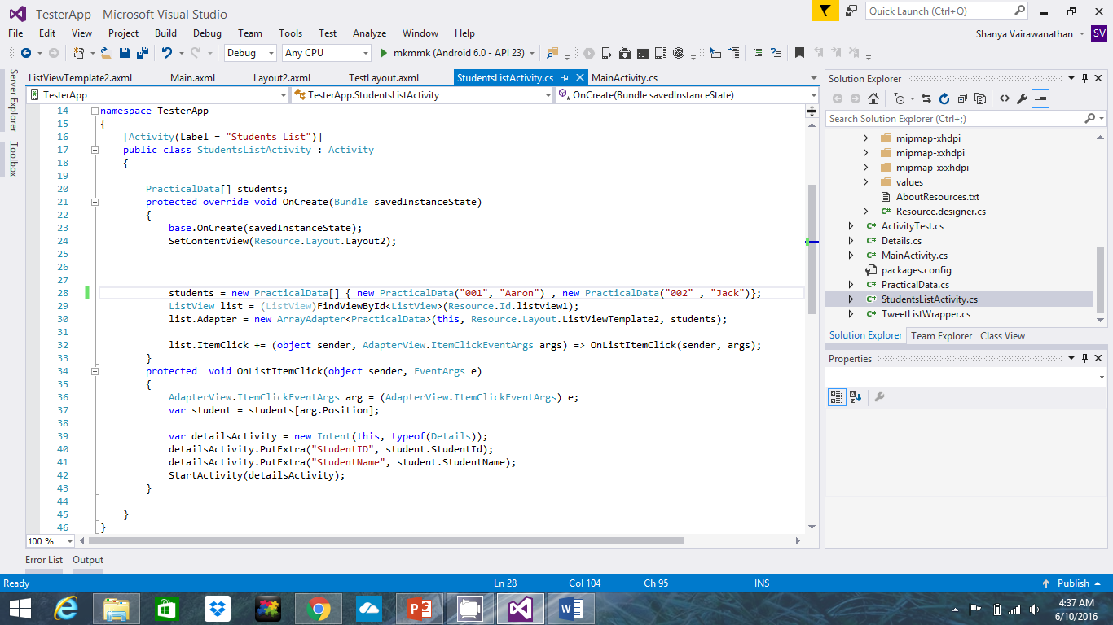> Enter this code on the StudentListActivity class .cs file

>This class basically adds student data into the student array, it connects the listview to the listview1 defined in the axml file which allows the list to be displayed on the app.

>When you run the app it will look like this:

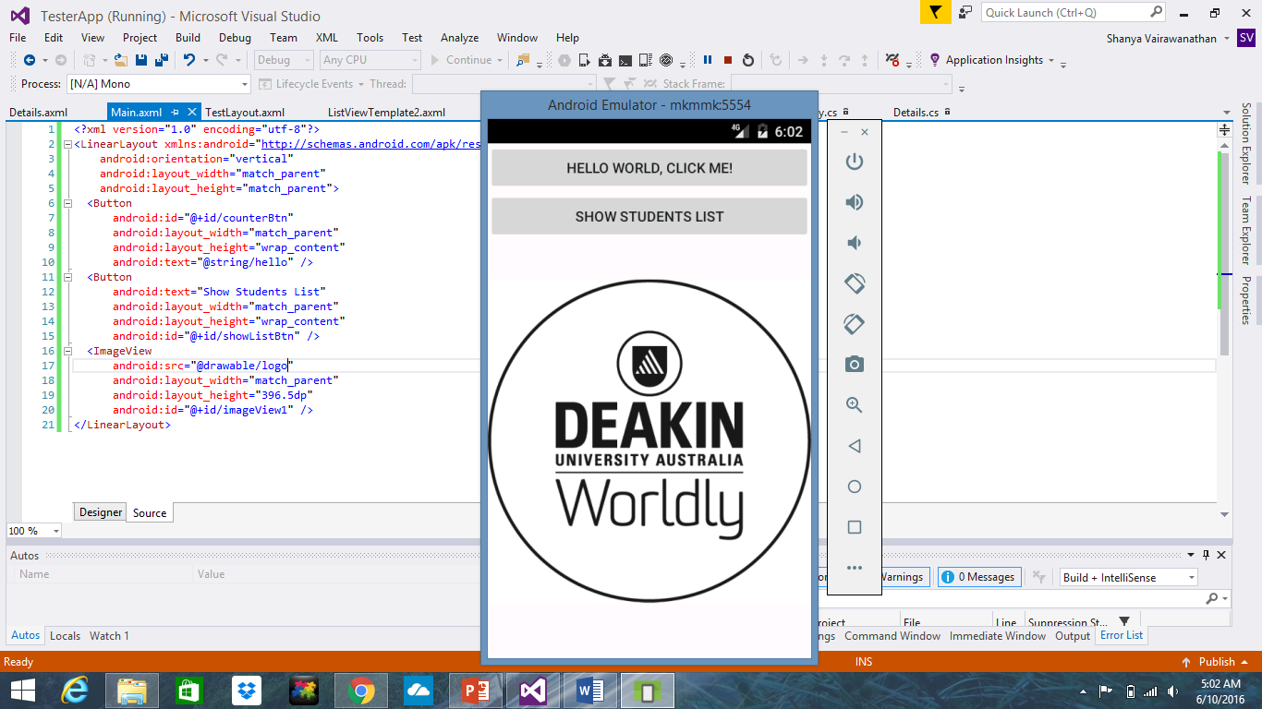

> When you click on the Show student’s list button the student’s list will appear.

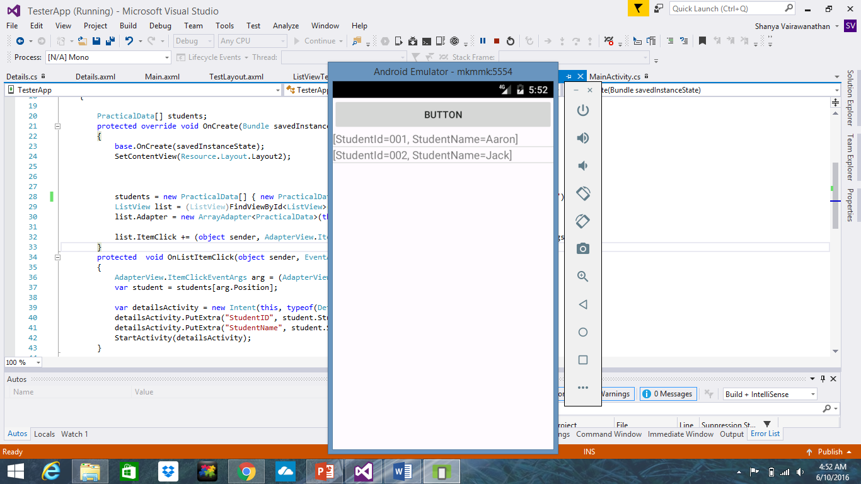

> In order to get that output, create another class called PracticalData and define the output and the parameters.

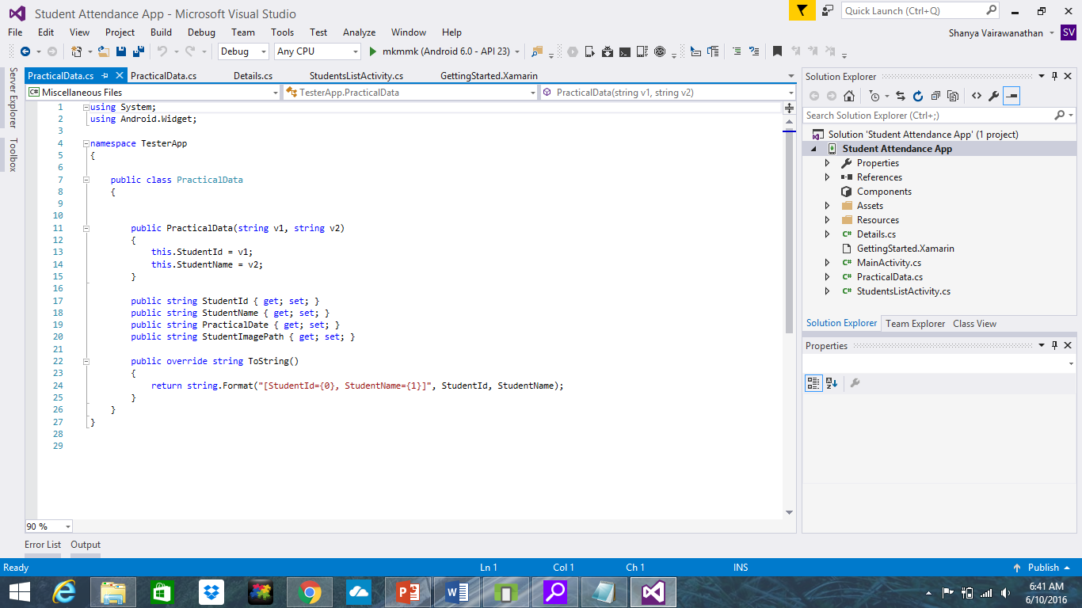

**Adding the camera to the app**

> Create a Details class

> Create and enter this code in the Details.axml file which creates the layout as it.

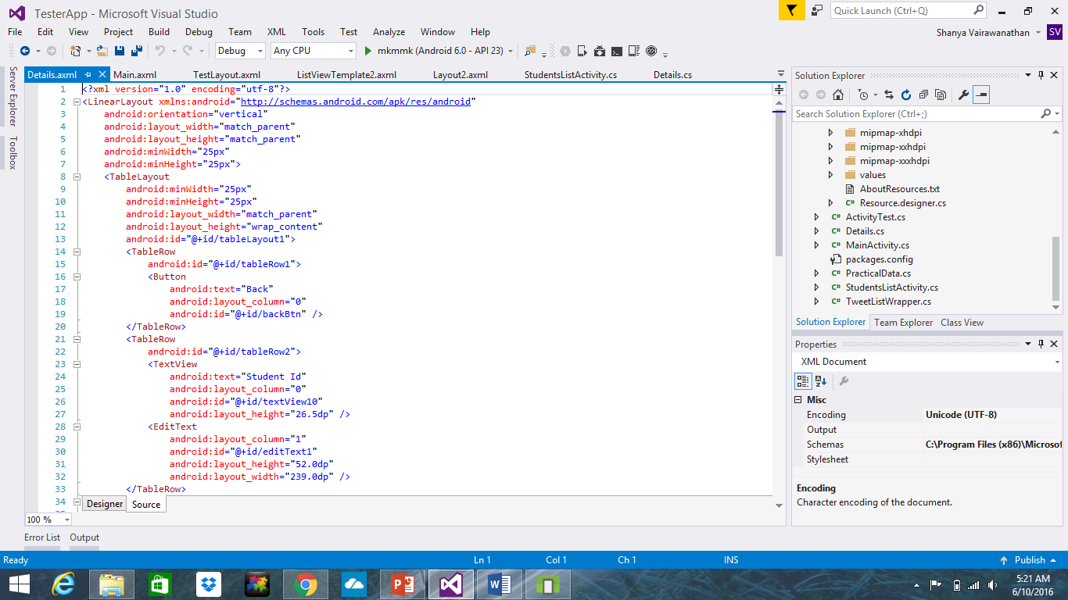

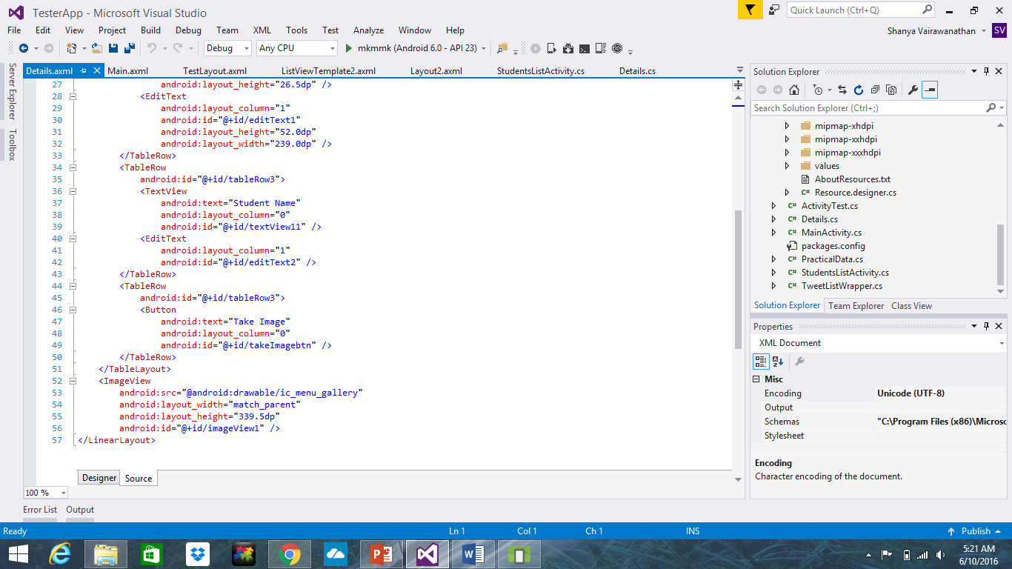

> Enter the following code in the Details.cs file. This code will display the student details, checks if the device has a app to take pictures, opens the camera if there is a camera, captures an image of the student, displays it on the screen and saves the image in a directory created.

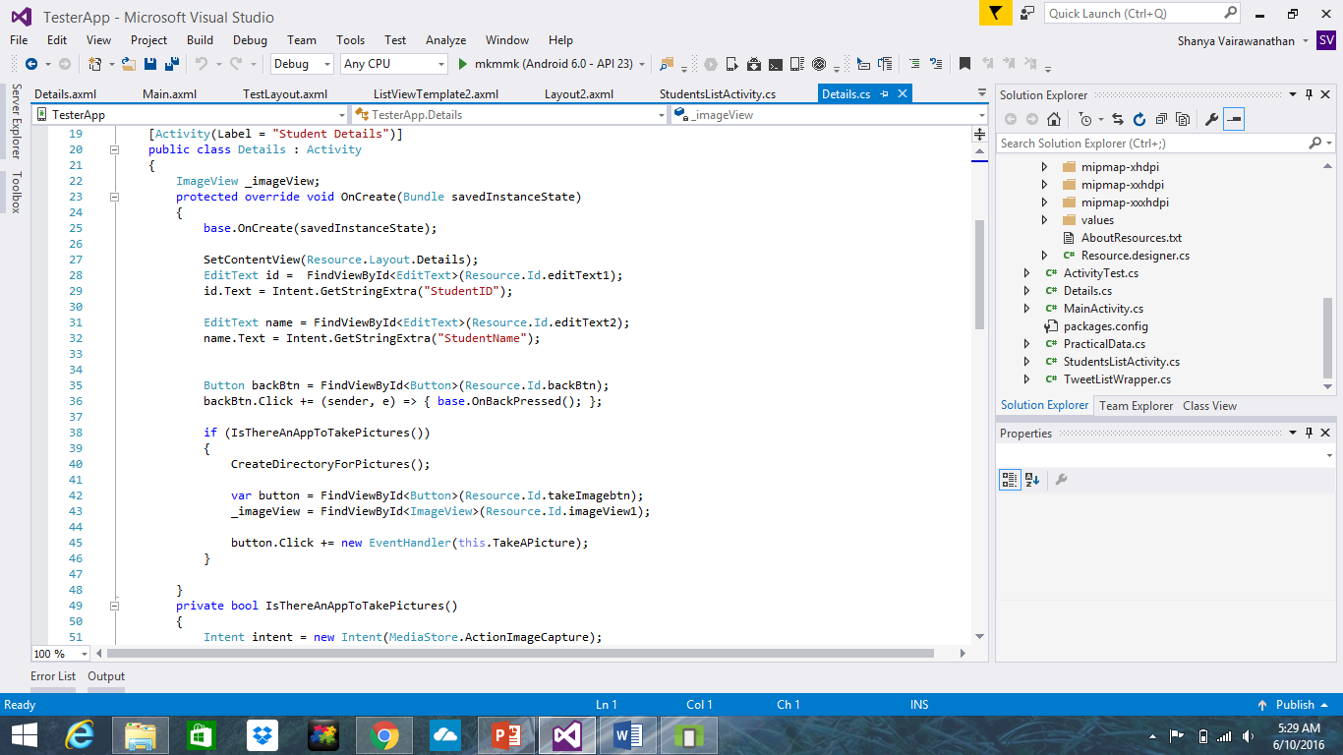

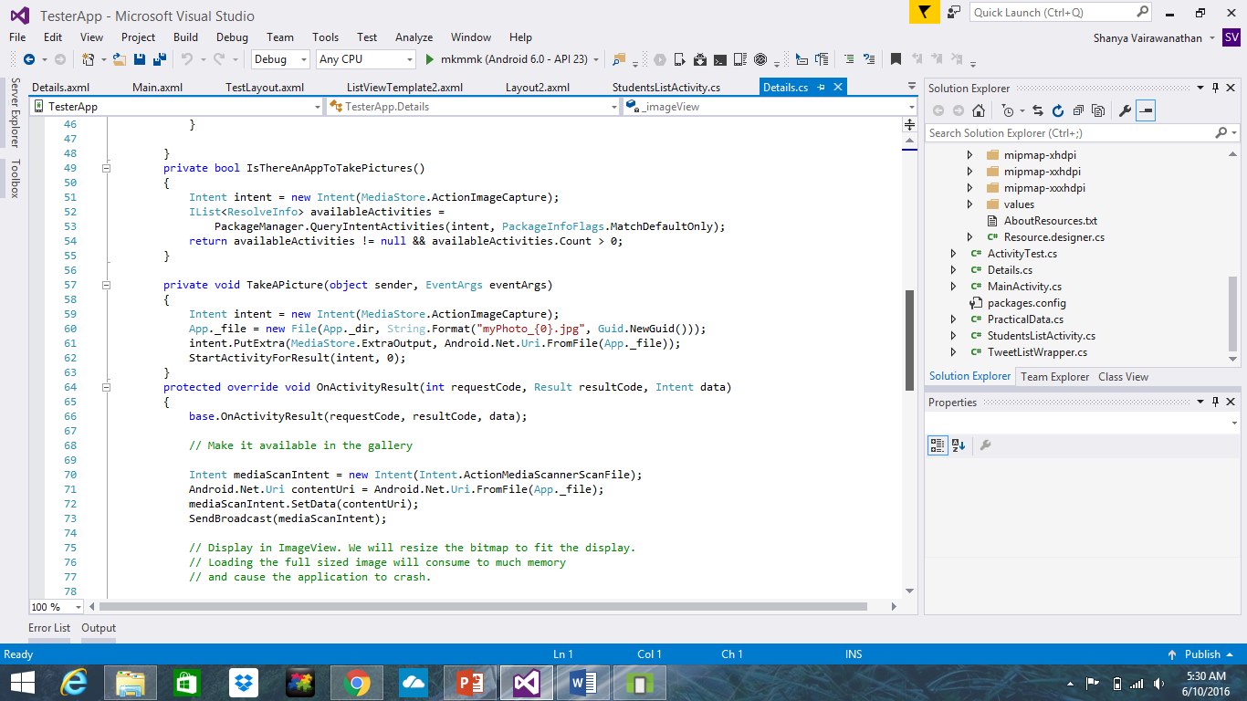

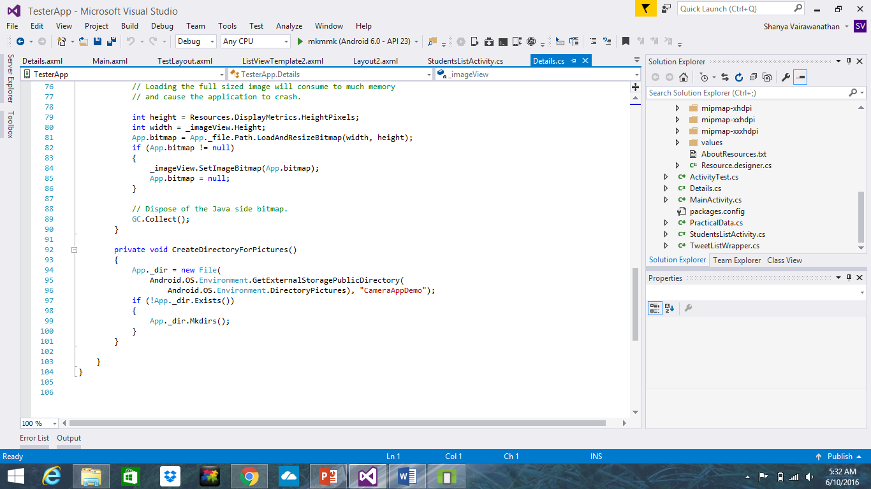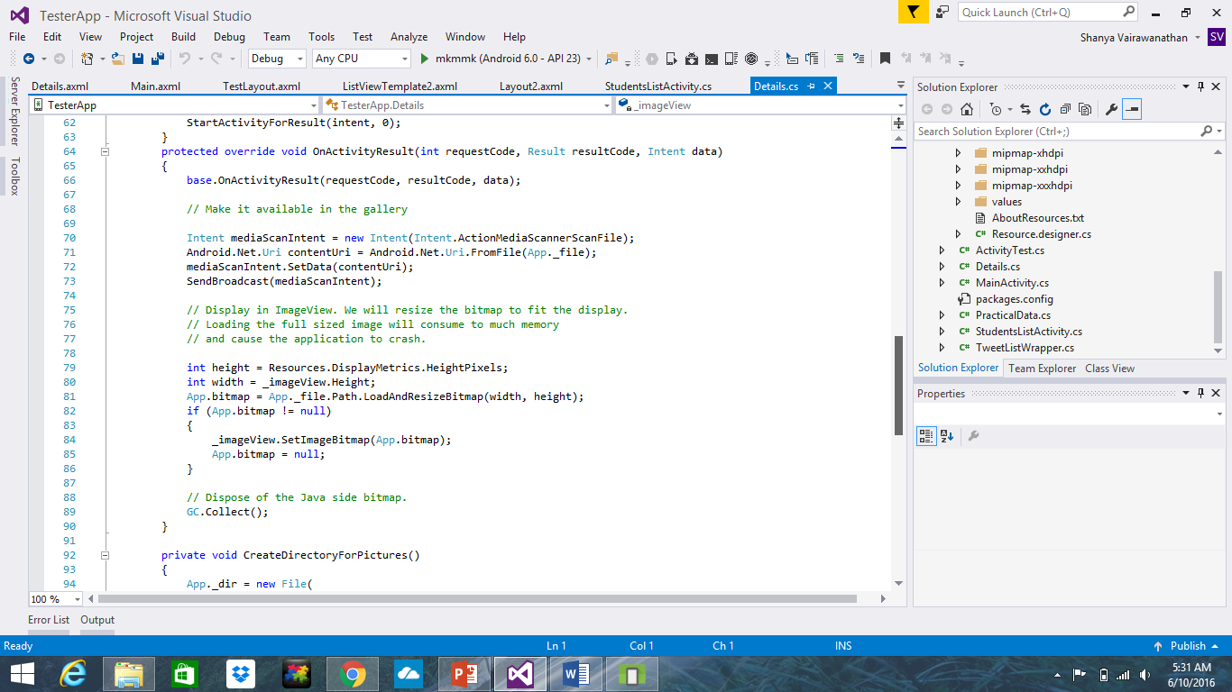

> From the Student list page, when you click on a specific student (I selected Aaron), the following will appear on the device.

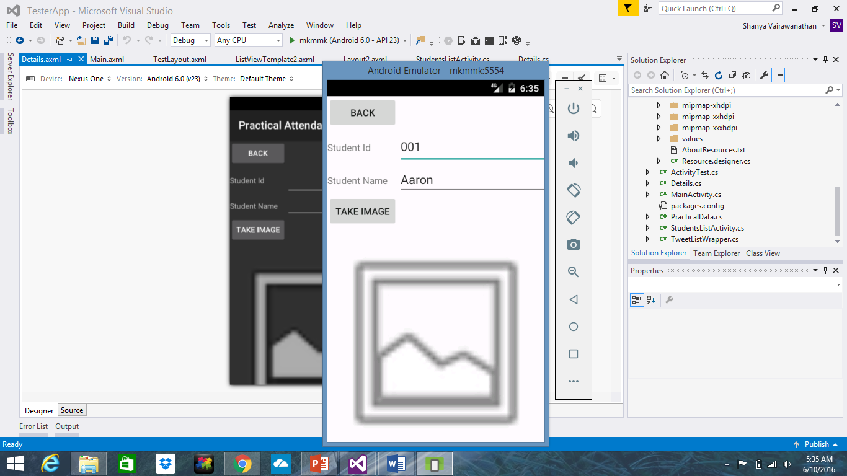

> When the “take image” button is clicked; the app will open the camera app in your phone. (Since I am testing the app using the computer emulator, it does not detect a camera. However, if it is run on an android device, the camera will open. (Notice the camera interface at the back of the error message).

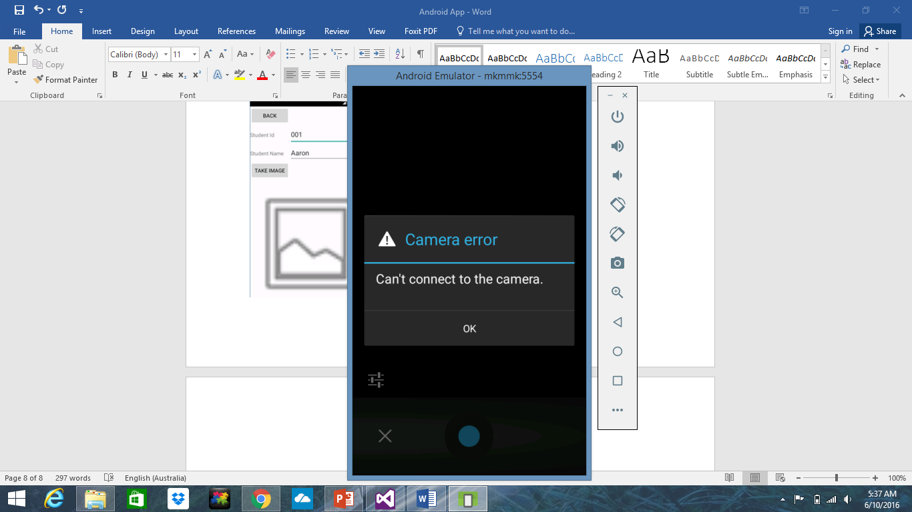

**Capabilities of this app:**

-Implementing images using the axml file layout  
-Implementing student data using ListView  
-Displaying stored data on another page  
-Connecting the camera app to the attendance app  
-Save the image into a directory created

**Watch the whole demo of this app running on**

[**https://youtu.be/4opiHjxlvs8**](https://youtu.be/4opiHjxlvs8)

**Find the code for this app on GitHub on this link**

[**https://github.com/svairawa/Xamarin.AndroidApp**](https://github.com/svairawa/Xamarin.AndroidApp)